## To creating a new branch

* **Create a new file**

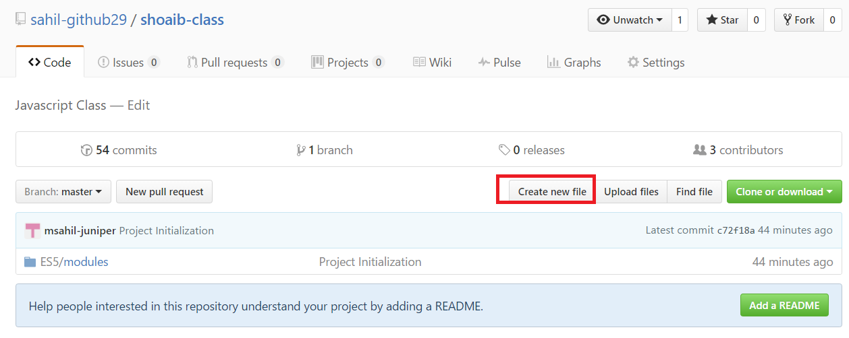

* **Enter file name**

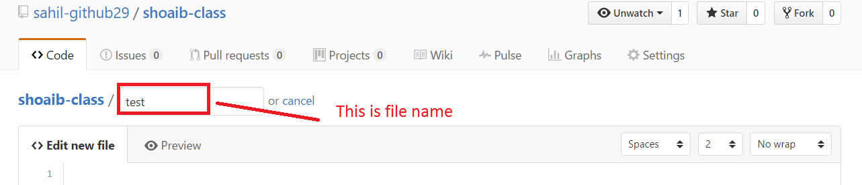

* **Create new branch**

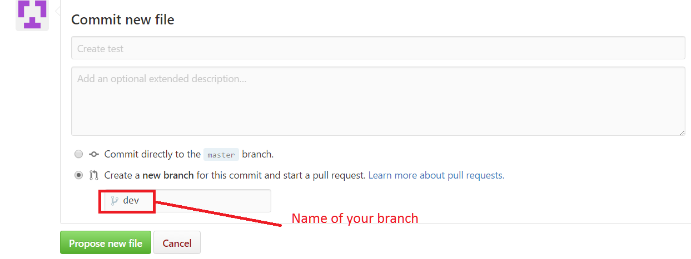

## To delete git branch

* git push origin --delete <branch name>

## Removing collaborator permissions from a person contributing to a repository

* On GitHub, navigate to the main page of the repository.
* Under your repository name, click Settings.
* In the left sidebar, click Collaborators & teams.
* Next to the collaborator you want to remove, click the X icon